MAWLANA BHASHANI SCIENCE AND TECHNOLOGY UNIVERSITY
SANTOSH, TANGAIL-1902



DEPARTMENT OF INFORMATION AND COMMUNICATION TECHNOLOGY
Lab Report

Lab Report No : 01
Lab Report on : Generation and analysis of elementary discrete-time signals using MATLAB.
Course Title : Digital Signal Processing Lab
Course Code : ICT-3206

Submitted By | Submitted To
Name: Kuldip Saha Mugdha  ID: IT-22018  3rd Year, 2nd Semester  Session: 2021-2022  Dept. of ICT, MBSTU | Dr. Mst. Nargis Akter  Professor  DEPARTMENT OF INFORMATION AND COMMUNICATION TECHNOLOGY  MAWLANA BHASHANI SCIENCE AND TECHNOLOGY UNIVERSITY

Date of Performance: 13/10/25 Date of Submission: 28/10/25
Introduction:
Digital Signal Processing (DSP) deals with signals that are defined at discrete instants of time. Elementary discrete-time signals such as unit impulse, unit step, ramp, parabolic, exponential, and sinusoidal signals are the basic building blocks of more complex signals. Understanding their behavior is essential for analyzing and designing digital systems. This experiment demonstrates the generation and operation of these signals using MATLAB.

Objective:
- To generate elementary discrete-time signals.
- To generate exponential sequences for different values of parameter $a$.
- To perform multiplication of two discrete-time signals.

Theory:
- Unit Impulse: $δ(n)=1$at $n=0$, otherwise 0.
- Unit Step: $u(n)=1$for $n≥0$, otherwise 0.
- Unit Ramp: $r(n)=n$, for $n≥0$.
- Unit Parabolic: $p(n)=\frac{1}{2}n^{2}$, for $n≥0$.
A discrete-time exponential signal is defined as
$$x(n)=a^{n}$$
- $0<a<1$: Decaying
- $a>1$: Growing
- $-1<a<0$: Decaying oscillation
- $a<-1$: Growing oscillation
Signal multiplication is given by
$$y(n)=x_{1}(n)⋅x_{2}(n)$$
MATLAB Code:

Program 1: Generation of Elementary Discrete-Time Signals
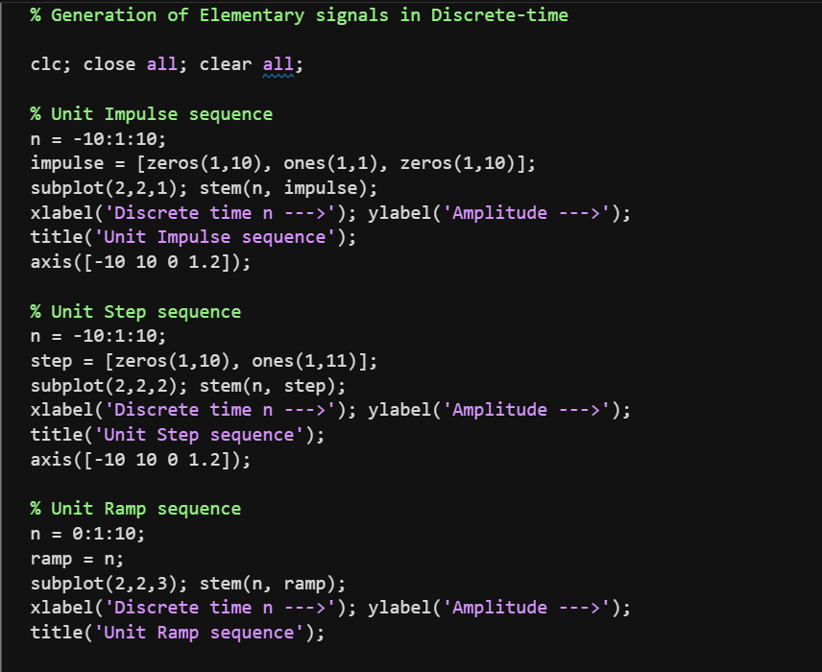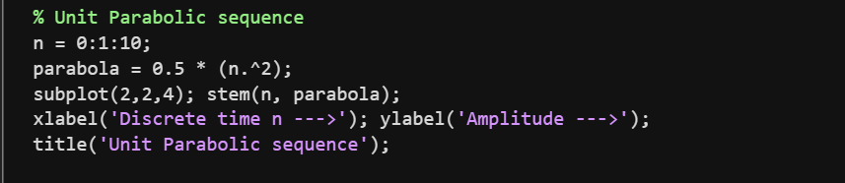
Output:
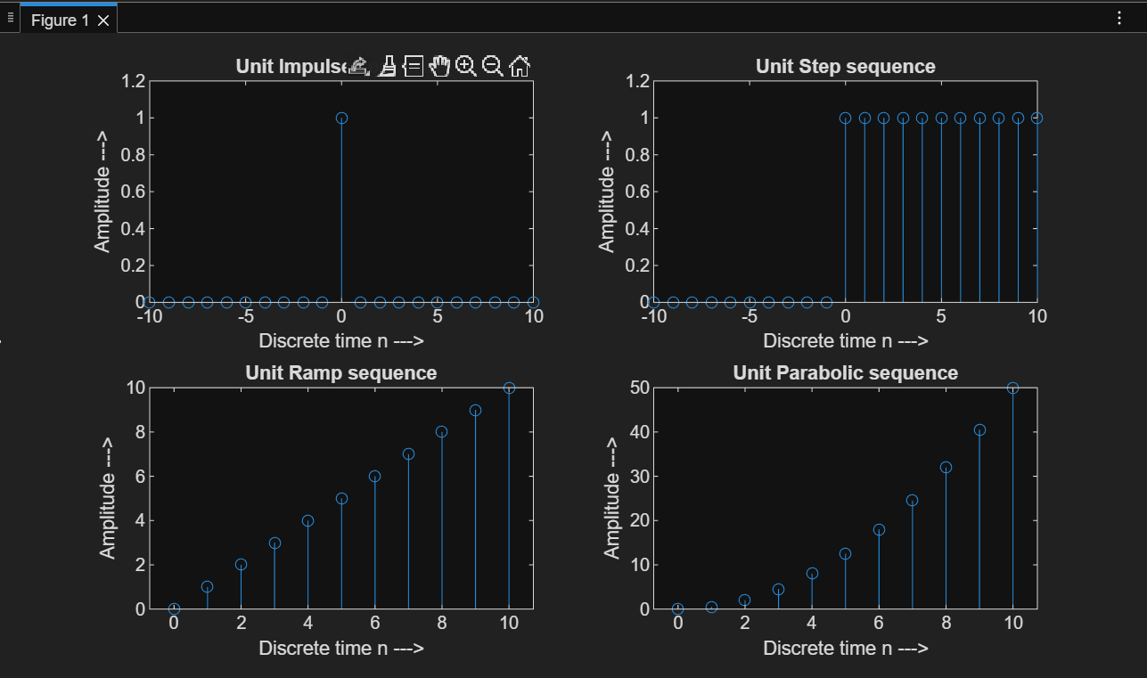
Program 2: Generation of Discrete-Time Exponential Signal
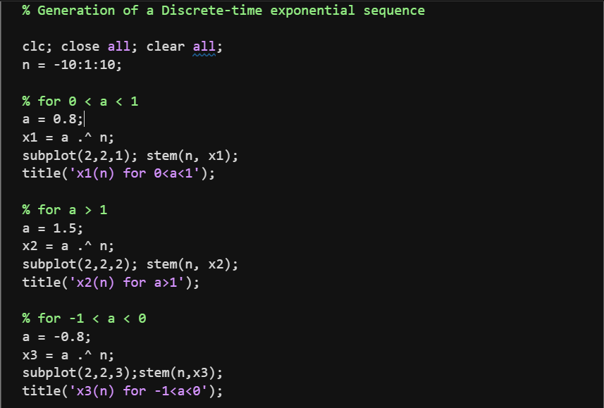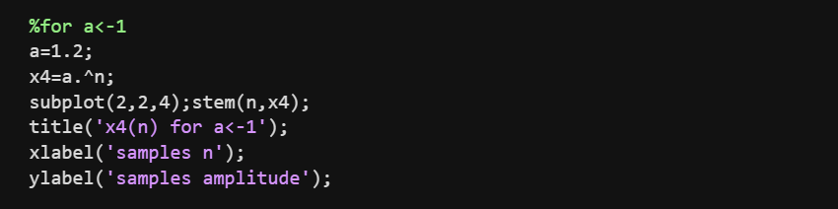
Output:
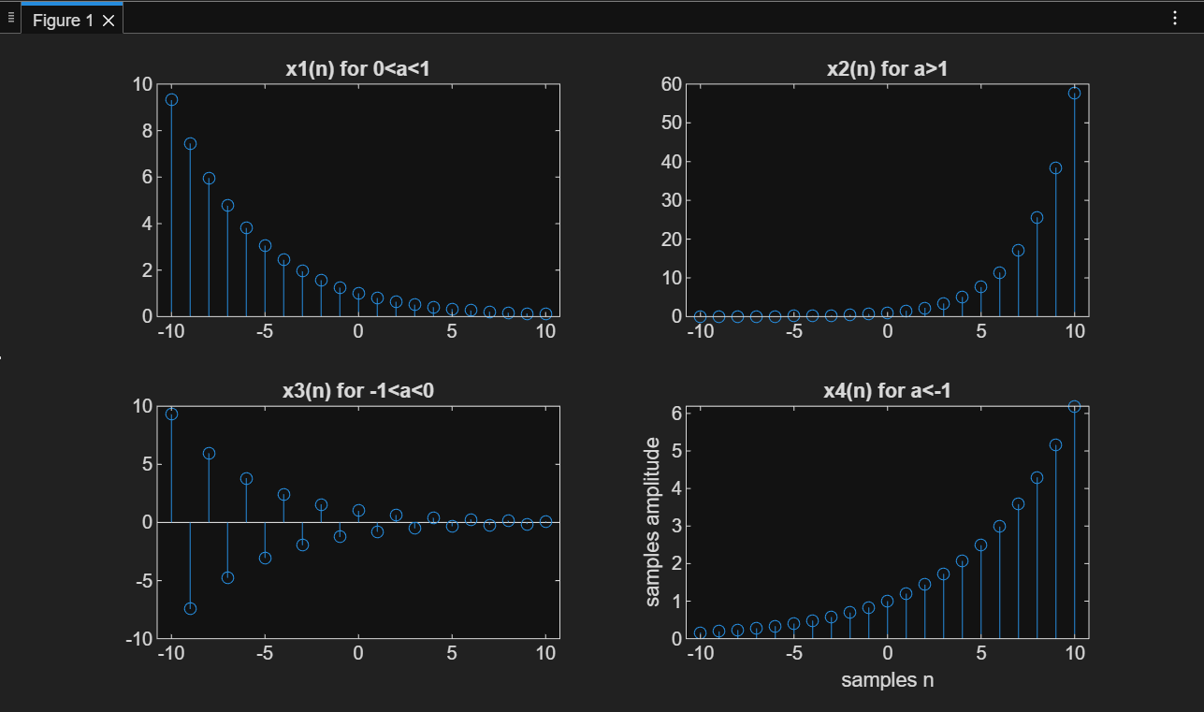
Program 3: Multiplication of Two Discrete-Time Signals
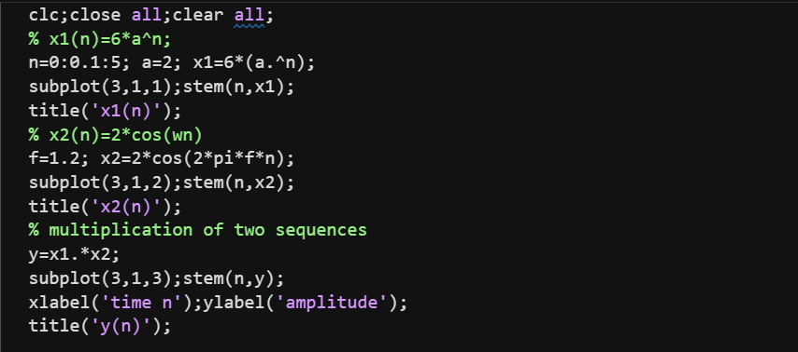
Output:
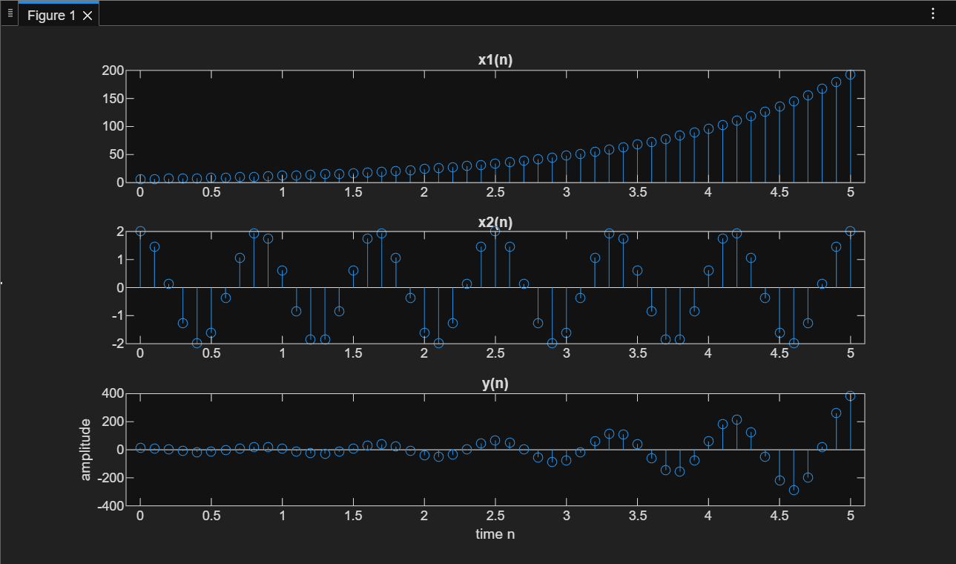

Result:
- Elementary discrete-time signals were generated successfully.
- Different exponential behaviors were observed for different values of $a$.
- The multiplication of exponential and cosine signals produced a modulated output.

Conclusion:
This experiment successfully demonstrated the generation and analysis of basic discrete-time signals and their multiplication using MATLAB. These signals form the foundation of digital signal processing.

